Thomas N. Burrows
Biography

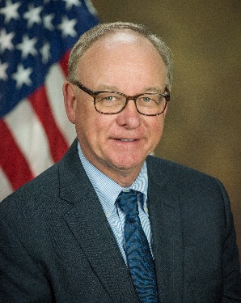

Tom Burrows is an Associate Director of the Office of International Affairs for the U.S. Department of Justice. He supervises extradition and mutual legal assistance cases involving more than 50 countries. He also specializes in negotiating information sharing agreements on organized crime and terrorism, as well as data privacy arrangements.

Mr. Burrows has nearly 20 years of experience as a prosecutor. He prosecuted homicides and other violent crimes in the Manhattan District Attorney’s Office. In the Justice Department, he has prosecuted public corruption cases, led a task force that investigated and prosecuted terrorism against abortion clinics, and supervised prosecutions of child pornography and other child exploitation crimes. In 1999 and 2000, he helped the US negotiate the UN Transnational Organized Crime Convention, particularly the Protocols to Combat Trafficking in Persons and Smuggling of Migrants. He has trained prosecutors, police, judges and parliamentarians in many parts of the world regarding the requirements and the opportunities for cooperation under the UNTOC. Mr. Burrows has chaired the International Cooperation Working Group of the UNTOC Conference of the Parties since 2010.

From 2012-2018, Mr. Burrows served on the Executive Committee of the International Association of Prosecutors. He has been active in the IAP since 1998, having spoken at numerous conferences and been involved in several projects to advance the interests of the IAP.

He is a graduate of Kent State University and New York University School of Law.

