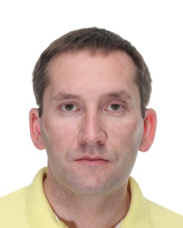

Taavi Pern

- Started working in Tallinn, Northern District Prosecutor’s office as an assistent prosecutor to prosecutor working on the local level drug crime (2005-2007)
- Since 2007 I worked as a district prosecutor in the same office – leading the investigations regarding local level drug crime (2007-2013)
- On 2013 I was appointed a State Prosecutor – I was specialized on drug trafficking cases (2013-2015)
- From 2015 – 2019 I was the Chief Prosecutor of Northern District Prosecutor’s Office – leader of the prosecutor’s office leading of criminal investigations in Tallinn and surrounding area
- From 2019 – to present day – Chief State Prosecutor. I work as a head of prosecution department in the office of the Prosecutor General. This department is responsible for criminal proceedings regarding most serious crime in Estonia incl. cybercrime.

