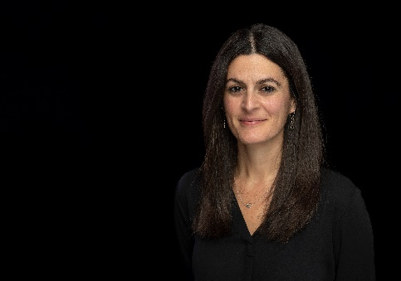
SHENAZ MUZAFFER
Shenaz Muzaffer is currently General Counsel of the International Association of Prosecutors (IAP), the only worldwide network of prosecutors. She joined the IAP in January 2023 on secondment from her role as a Deputy Chief Crown Prosecutor at the Crown Prosecution Service of England and Wales (CPS). Prior to her secondment, she was the Head of the International Division of the CPS and also one of the deputy Heads of the Serious Economic Organised Crime and International Division.
Shenaz holds an LLB (Hons) (1st Class) from the University of Nottingham, and is a member of the Bar of England and Wales.
Shenaz spent eleven years prosecuting the full range of criminal offences, including serious sexual and violent offences, drugs offences, homicide and complex fraud, before joining the International Division of the CPS. Between 2013 and 2015 she was seconded as State Counsel and criminal justice advisor to the Attorney General’s Office in Seychelles, working as part of the UK’s counter-piracy mission. She then spent eighteen months as an asset recovery adviser and liaison prosecutor based in the United Arab Emirates, promoting cooperation between the UK and the UAE prosecutorial agencies and working to facilitate the progress of mutual legal assistance requests and extradition requests between the UK and the UAE. From 2016, she spent three years as the UK’s liaison prosecutor to the USA, advising on mutual legal assistance and extradition issues between the UK and the USA in relation to the investigation and prosecution of transnational and serious organised crime, promoting the use of informal channels of assistance, encouraging greater cooperation between criminal justice agencies, and assisting UK investigators and prosecutors to draft and progress formal requests for mutual legal assistance in criminal matters. She took up the position of Head of the International Division in August 2019, where she was responsible for overseeing a network of CPS liaison prosecutors deployed overseas in up to twenty countries and leading for the CPS in relation to their international engagement.

