Mr. Renato Finocchi Ghersi
Advocate General, Supreme Court of Cassation
Italy

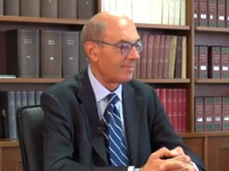
He has been a member of the judiciary since 1980, and he has performed his functions as a judge and as a public prosecutor.
Since 2001, he has performed the judicial functions at the Prosecutor General’s Office of the Supreme Court of Cassation, at Appeal Court level first and then at Supreme Court level, working in civil and in criminal matters.
Since 2018, he has filled an executive role, as Advocate-general of the Prosecutor General’s Office at the Supreme Court of Cassation.
As such, he has led the Service for civil affairs, by coordinating Deputy Prosecutors General who plead in front of the highest panel of the Supreme Court in Joint Sessions.
Besides, he has also led the Office for International Affairs of the Prosecutor General’s Office at the Supreme Court of Cassation. As a delegate of the Prosecutor General, he participates to international activities, and he represents the Prosecutor General’s Office in various organizations, such as the Network of Prosecutors General and Equivalent Institutions in Supreme Courts of the European Union (Nadal Network), and the yearly Forum of Prosecutor General at Eurojust.
On several occasions, he performed executive functions beyond his role within the judiciary.
He was Head of the Minister of Justice’s Cabinet during the Government led by PM Enrico Letta (2013-2014). He was Head of the Minister of Health’s Cabinet during the government led by PM Romano Prodi (2006-2008); he was the Head of the legislative Office of the Minister for Social Affairs (1996-2001) during the governments led by PM Romano Prodi, PM Massimo D’Alema and PM Giuliano Amato.
He has been research clerk at the Constitutional Court from 1991 to 2000, working with the Constitutional Judges, Hon. Enzo Cheli and Hon. Valerio Onida.
He has taught in different universities and participated to courses at the High Council of the Judiciary.
From 2001 to 2005, he has been Adjunct Professor at Tuscia University (Viterbo).
He spent study visits abroad and he was visiting scholar at the Center for International Affairs, Harvard University, Nuffield College, and Oxford University.
He is the author of several publications on immigration, reform of the Civil Service, National Health Service and, more recently, on economic and manufacturing activities.

