Olivia Rose, Deputy Chief Crown Prosecutor, Crown Prosecution Service

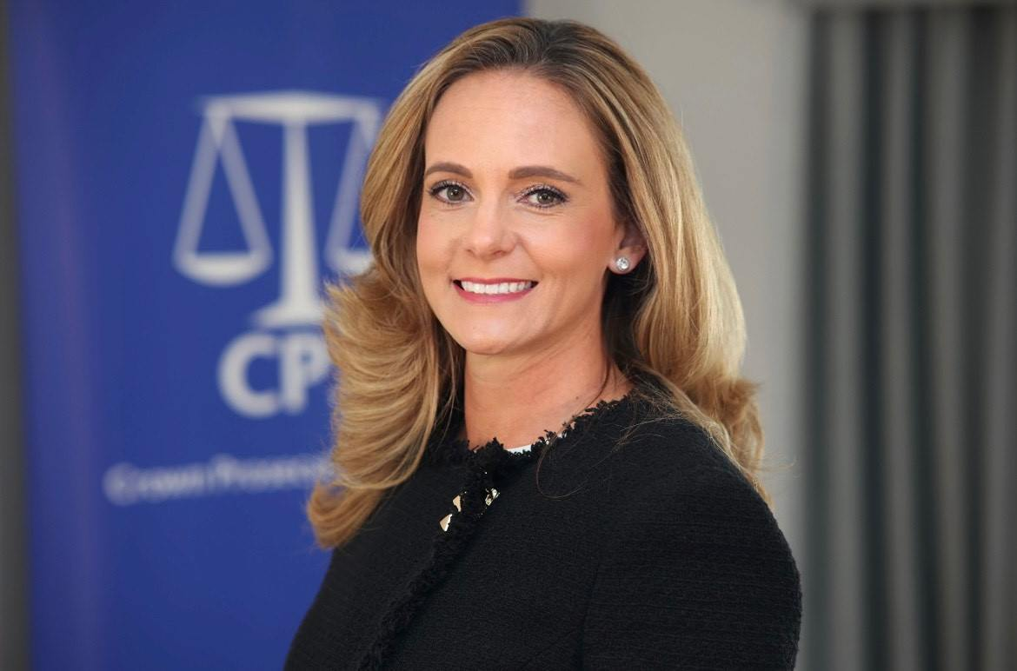
Olivia is the Deputy Chief Crown Prosecutor for CPS Thames and Chiltern with responsibility for the Rape and Serious Sexual Offences Unit and the Magistrates’ Courts Team.
Before taking up her current role in 2019, she worked for the Government Legal Department as a Senior Advisory Lawyer, initially at the Department of Work and Pensions and then at the Cabinet Office working on Brexit ‘no deal’ contingency planning.
Olivia was previously a Senior Legal Advisor with the Attorney General’s Office working in the Public Law and Litigation team, and prior to this worked for the CPS for nine years in the East of England - three years as a Senior Crown Prosecutor and then six years as a District Crown Prosecutor.
Olivia is the Crown Prosecution Service’s national lead for stalking and harassment and the deputy lead for domestic abuse, working with the various local leads across the country to share knowledge and identify themes and trends, so that the CPS can continue to secure justice for victims and take steps to prevent repeat offending.

