Michael LEITNER
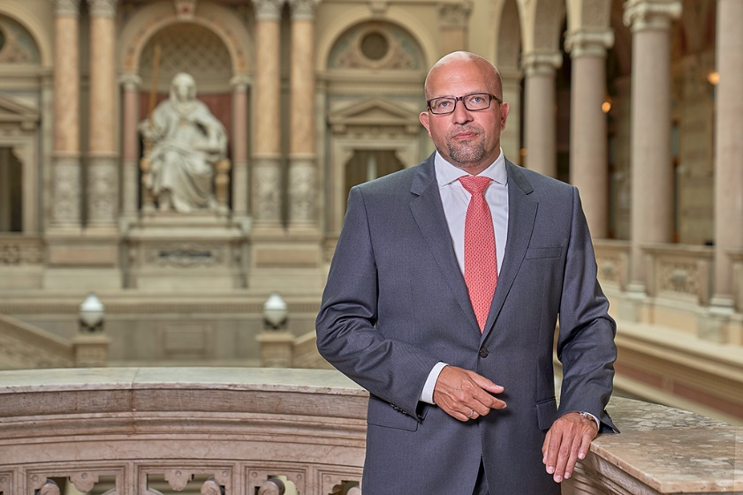

Mr. Leitner was appointed a Deputy Procurator General of the Austrian Procurator General´s Office in 2012. Previously, he had been serving as judge of a District Court in Vienna (2002-2003), as Public Prosecutor at the Vienna Public Prosecution Office (2003-2007), as advisor at the Austrian Federal Ministry of Justice (2007-2009) and as Senior Public Prosecutor at the Public Prosecution Office at the Vienna Court of Appeal (2009-2011).
Besides his role as Deputy Procurator General he is active as a member of the board of the Austrian Association of Prosecutors, as a member of the board of directors of the International Association of Penal Law (AIDP/IAPL) and as a member of the Consultative Council of European Prosecutors at the Council of Europe (CCPE).
In 2022 he was elected as a member of the IAP Executive Committee.

