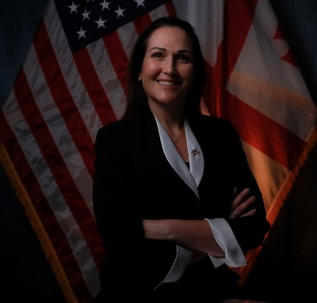
Assistant U.S. Attorney (AUSA) Lana Owens is a federal prosecutor in the Criminal Division of the U.S. Attorney’s Office in the Central District of California, a position she has held since 2008. Since 2021, RLA Owens served as the DOJ OPDAT (Overseas Prosecutorial Development, Assistance and Training) Director and Resident Legal Advisor for Embassy Tbilisi, a position funded by the U.S. Bureau of International Narcotics and Law Enforcement Affairs. In this capacity, RLA Owens works with the Prosecutor General’s Office, Ministry of Justice and other justice sector institutions and actors to strengthen Georgia’s legal framework and capacity to combat complex crimes, as well as adhere to Euro-Atlantic principles of rule of law. Before joining Embassy Tbilisi, RLA Owens was assigned to Embassy Pristina for three years where she mentored prosecutors at the Special Prosecution Office, helped with the adoption of Sentencing Guidelines, and assisted in drafting and adopting new legislation governing the evaluation and discipling prosecutors, and revised laws on the Anti-Corruption Agency, the Prosecutorial Council, and the selection of the Chief State Prosecutor to name a few.

Prior to her detail with OPDAT, RLA Owens worked in Los Angeles, California prosecuting cases involving corruption, human trafficking, crimes against children, organized crime, fraud, and money laundering. Additionally, she served as her office’s arson and human trafficking coordinator, as well as supervised junior AUSAs and interns. Before becoming a federal prosecutor, RLA Owens clerked for a United States District Court Judge and spent three years practicing white collar criminal defense for Latham and Watkins.

RLA Owens earned her undergraduate degree at San Francisco State University and her Juris Doctorate at the University of California, Berkeley.

