Katarina Johansson Welin

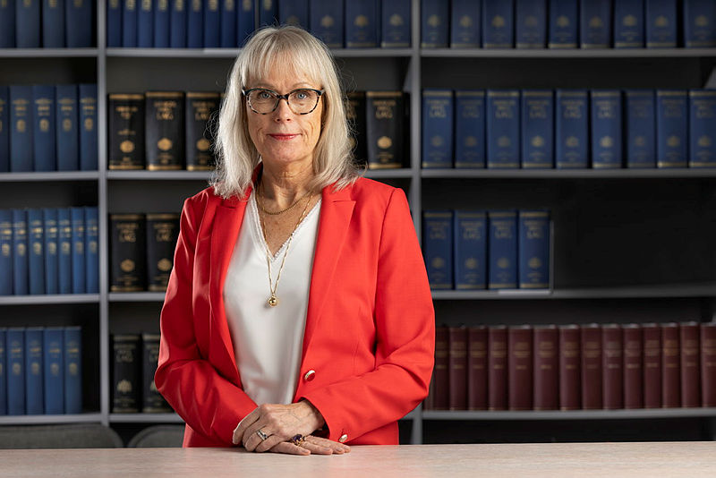

Biographical note

Katarina Johansson Welin is the acting Prosecutor General at the Swedish Prosecution Authority. Ms Johansson Welin has a master of law from Lund University. She has worked in public prosecution since 1991. During these years, Ms Johansson Welin has, among other things, been Chief Public Prosecutor at the National Unit against International Organised Crime and Head of Stockholm Public Prosecution Area (Director of Public Prosecution). Ms Johansson Welin has been the Swedish Prosecution Authority´s expert in several Official Reports of the Swedish Government.

Mail address | Office | Tel: | E-mail
 |  | Fax: | Webb address  www.aklagare.se

