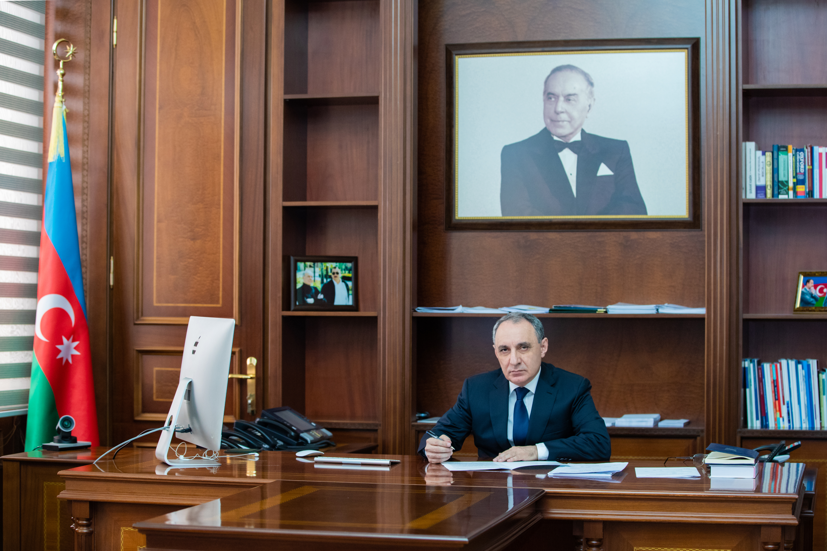

Dr. Kamran ALIYEV
Prosecutor General of the Republic of Azerbaijan
Kamran Aliyev was born on November 18, 1965 in Balakan city. In 1987 he graduated with honors from the Faculty of Law of Irkutsk State University (Russia) and was appointed as an intern to the position of investigator of the Chita Transport Prosecution Office of the Trans-Baikal Transport Prosecution Office of the Russian Federation. Later K. Aliyev worked as a senior investigator of this prosecution office and in the Trans-Baikal Transport Prosecution Office. In 1990-1993, he studied at the full-time department of the Scientific Research Institute of the USSR Prosecutor General's Office, at the same time worked as a research fellow. In 1993 he defended his thesis and received PhD in Law. Later Kamran Aliyev entered the prosecution office of the Republic of Azerbaijan. He worked in positions of prosecutor of the Personnel Department, Head of the Scientific and Educational Center, investigator and senior investigator of the Investigation Department and the Investigation Department for Grave Crimes of the Prosecutor General's Office, assistant and senior assistant to the Prosecutor General, director of the Department for Public Prosecutions Defense of the Prosecutor General's Office. On 06.08.2007, he was appointed Director of the Anti-Corruption Department with the Prosecutor General of the Republic of Azerbaijan. By the order of the President of the Republic of Azerbaijan dated 05.08.2014, K.Aliyev was appointed Deputy Prosecutor General of the Republic of Azerbaijan - Director of the Anti-Corruption General Directorate with the Prosecutor General of the Republic of Azerbaijan. K.Aliyev has a PhD in Law. Fluent in English and Russian. State Counselor of Justice, II degree. By the order of the President of the Republic of Azerbaijan dated September 27, 2008, he was awarded the "Flag of Azerbaijan" order. By the order of the President of the Republic of Azerbaijan dated September 28, 2018, he was awarded the Order of Merit for the Motherland, 2nd degree. K.Aliyev is Vice-President of the International Association of Prosecutors, a member of the Azerbaijani delegation to the Group of States against Corruption (GRECO) of the Council of Europe. In addition, he is the National Coordinator for the implementation of the Istanbul Anti-Corruption Network Action Plan in Eastern Europe and Central Asia of the Organization for Economic Cooperation and Development (OECD). By the order of the President of the Republic of Azerbaijan dated May 1, 2020, he was appointed Prosecutor General of the Republic of Azerbaijan. By the order of the President of the Republic of Azerbaijan dated November 23, 2021, he was awarded the highest special rank of State Counselor of Justice of the 1st degree. He is married and has two children.

