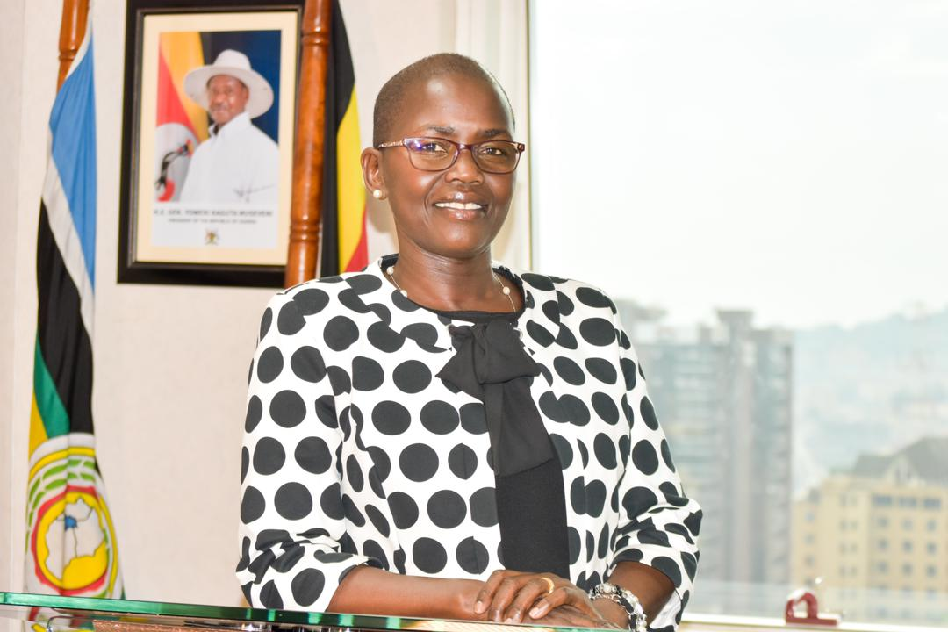

BIBOGRAPHY
JANE FRANCES ABODO
Jane Frances ABODO is the Director of Public Prosecutions (DPP) of Uganda, and the First Female DPP in Uganda. She was appointed DPP in March 2020.
Previously, she was a Judge of the High Court, a position she assumed in 2018. She was attached to the Criminal Division where she was the Focal Point Person for Plea Bargaining and SGBV Cases. Jane worked in the Office of Director of Public Prosecutions for 19 years in various capacities before she became a Judge. Jane was a recipient of the Best Female Prosecutor of the year Award in 2015.
She has a Master in Laws (LLM) from Trinity College Dublin, Ireland, and Master in Conflict Studies from Makerere University, Post Graduate Diploma in Legal Practice, LLB Makerere University Kampala, and Post Graduate Diploma in Human Resource Management of Uganda Management Institute. She is currently pursuing a PHD at UNICAF University.
In addition, she has trained extensively in Anti-corruption, Money Laundering, Financial Investigations, Asset Recovery, Sexual and Gender based Violence and Plea Bargaining.

