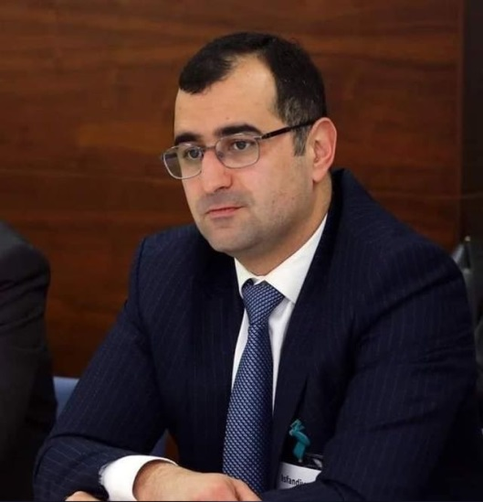
Isfandiyar Hajiyev
Biographical note
Isfandiyar Hajiyev is the Deputy Head of the Organizational and Information Support Department at the Anti-Corruption Directorate with the Prosecutor General of the Republic of Azerbaijan. He is in charge of cooperation with international organizations and implementation of international standards at the Prosecution Service. In his duties also included working on MLA regarding corruption crimes, analyze received information on corruption related offences and work with citizens.
Isfandiyar Hajiyev has considerable experience in participating, as country representative in international peer reviews mechanisms, including those conducted by UN and OECD Anti-Corruption Network. He is also responsible for cooperation (contact point) with the IAP, OLAF and EPAC/EACN.

