Bio

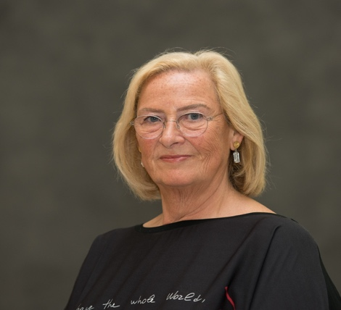

Edith Van den Broeck

Senior prosecutor Belgium – Senior Legal Advisor IAP

Officer of the Order of the Crown.
Grand Officer of the Order of Leopold II.

Studies
Degree in Law (University Institution of Antwerp).

Language skills: Dutch, French, English, Spanish, German

Passed the federal language examination (Article 38 §4 of the laws on the use of languages in administrative matters, applicable to the exercise of the functions classified in level 1/A of the civil servants)

Professional
Internship as a lawyer at the Bar in Mechelen from 1982 to 1985.

Judicial trainee at the Public Prosecutor's Office in Leuven on 1 January 1985.

Attaché cabinet Minister of Justice from 1986 to 1988.

Prosecutor at the Public Prosecutor's Office in Mechelen on 24 July 1986.

Senior Prosecutor at the Public Prosecutor's Office in Mechelen on 26 September 1991.

Founding member of the Permanent Bureau and Chairman of the High Council of Justice; Chairman of the Nomination and Designation Committee (BAC) from February 26, 2000, to November 30, 2007. (https://hrj.be/nl )

Representative for Belgium (HRJ) in the European Network for the Training of Magistrates (EJTN) since 2000, former member of the Steering Committee and chaired several times in this context in Brussels. (https://www.ejtn.eu )

Initiator and Representative for Belgium (HRJ) in the European Network of Supreme Councils (ENCJ), member of the Steering Committee from 2003 to May 23, 2008, President from May 1, 2007 to September 1, 2008. ( https://www.encj.eu )

Founding Director of Judicial Training, Training Institute for the Judiciary (IGO) from 1 December 2007 to November 2015.

Chairman of the Judicial Training Evaluation Committees until November 2015.

Seconded to International Association of Prosecutors (IAP), based in The Hague, since August 2015.

Miscellaneous
Member of the Federal Deontological Commission / Commission fédérale de Deontologie https://www.fed-deontologie.be/en

Member of the International Association of Prosecutors, https://www.iap-association.org

Member of the Advisory Board of the International Institute for Justice and the Rule of Law (IIJ), Malta, www.theiij.org

Founding chairman of the de facto association Law and Freedom Lier, https://rechtenvrijheid.be

Member of the core group of ambassadors of the circle of friends of Kazerne Dossin, https://kazernedossin.eu

