**CARL PROPHET** 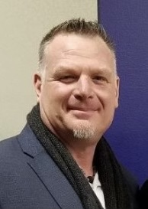

Carl has over 17 years experience as the Senior Executive in Charge of Safety and Security for the Ministry of Attorney General and the Ministry of Public Safety and Solicitor General of British Columbia with a specific focus on Prosecutor safety and security. In 2007 Carl was appointed under the Police Act to coordinate and promote security for BCPS members involved in the prosecution of organized crime and terrorism offences, and for the protection of BCPS members with respect to attempts to undermine the administration of the Criminal Justice System.

For the past 8 years he has acted as a Senior Advisor for programs sponsored by Global Affairs Canada and the Bureau of International Narcotics and Law Enforcement of the US State Department in the Northern Triangle. Carl has worked closely with Attorney Generals and Presidents of the Supreme Courts setting up safety and security programs for justice agencies in Guatemala, El Salvador, and Honduras.

Carl’s specialism is safety and security program design and implementation; he strives to create safety and security programs that provide the true risk mitigation his clients need. Carl is currently supporting Sean Penn’s foundation CORE and Frank Giustra’s foundation Accesso, providing protection services in Ukraine, Haiti, El Salvador, and Colombia.

In 2010, Carl was appointed as the Senior Executive for the 2010 Winter Olympics Provincial Asset Protection Team.

Prior to his time with the Attorney General Ministry, Carl served on Special Operations Units and Emergency Response Teams in both the Military and Law Enforcement. He holds professional designations in safety, business continuity, security, and anti-terrorism.

Carl received the World Safety Organization Glenn Hudson Award for work in Canada and Central America as it pertains to the safety and security of justice officals.