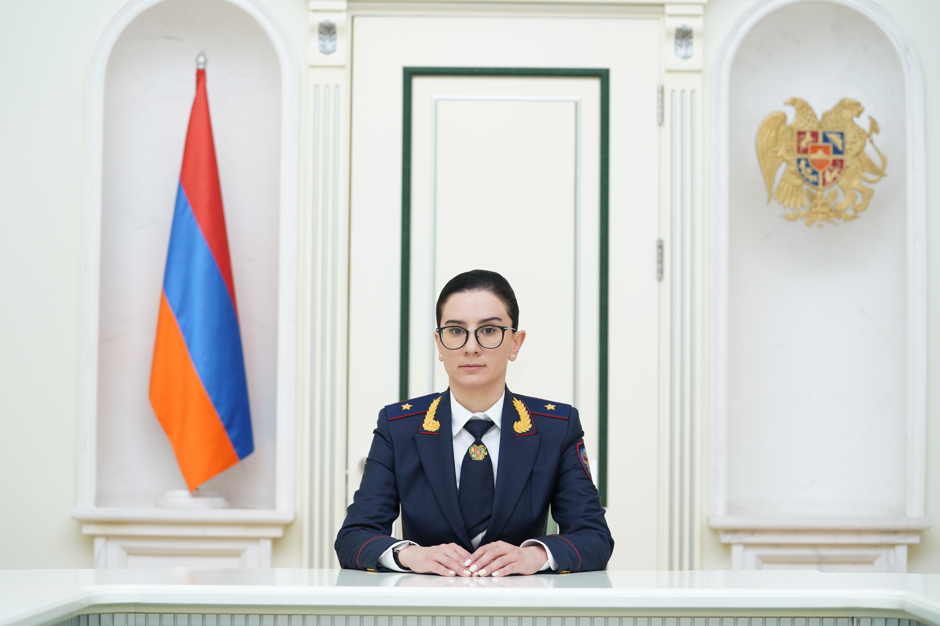 | ANNA K. VARDAPETYAN  Born on February 18, 1986 in Yerevan  Prosecutor General of the  Republic of Armenia  Third Rank State Counsellor of Justice

Mrs. VARDAPETYAN was elected as the Prosecutor General of the Republic of Armenia by the National Assembly on 29th June, 2022. Before assuming her office on September 15, 2022, she held, among others, the positions of the Assistant to the Prime Minister, Deputy Minister of Justice, First Deputy Head of the Judicial Department of the RA.
In her capacity of the Head of the Prosecutor’s Office Mrs. VARDAPETYAN demonstrates unparalleled mastery of legal principles, a strategic mindset and leadership powers. Mrs. VARDAPETYAN approaches every case with a sense of responsibility and diligence that reflects her deep respect to the legal profession. Furthermore, she is unconditionally committed to ethical standards and integrity.
Besides her professional experience, Mrs. VARDAPETYAN has extensive involvement in educational and scientific work, which she delivers as the lecturer in the Criminal Law Department of the Faculty of Law of Yerevan State University (since 2010) and as an associate Professor at the same Department (since 2017). She is an author and co-author of more than 20 scientific articles, scientific-practical manuals, analyzes and books.
Mrs. VARDAPETYAN earned the Doctorate Degree in Law, defending her dissertation on "Criminal Issues in Organ and (or) Tissue Transplantation to Human” on October 5, 2012.
She also is the Member of the Royal Institute of International affairs, London (since 2015) and the Member of the Board of Trustees of the "Yerevan State University" Foundation (since 2022).

Hereinafter the RA

