Mr Ang Cheng Hock, SC
Deputy Attorney-General

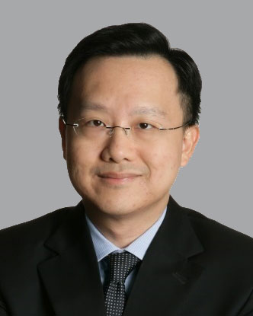

Mr Ang Cheng Hock, SC, graduated with a Bachelor of Laws (1st Class Honours) from the National University of Singapore in 1995 and a Master of Laws from Yale Law School in 1998. He served as a Justices’ Law Clerk in the Supreme Court in 1996 and 1997. He was called to the Singapore Bar in 1996 and admitted as an Attorney & Counsellor at Law in the state of New York in 1999.

Mr Ang joined Allen & Gledhill in 1999 and became a partner of the firm in 2000. His main areas of practice included civil and commercial litigation, international arbitration and corporate-related disputes such as shareholders’ disputes, breaches of directors’ duties, securities-related and banking litigation, defamation and professional liability. He had also represented clients in insolvency related litigation, shipping disputes and intellectual property disputes. He was appointed Senior Counsel in 2009.

Mr Ang was appointed Judicial Commissioner of the Supreme Court on 14 May 2018 and High Court Judge on 1 August 2019.

He was appointed and assumed office as Deputy Attorney-General on 1 October 2022.

