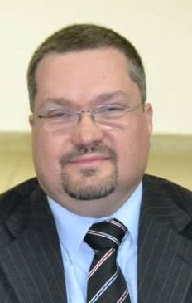
ANDRÉ LUIZ NOGUEIRA DA CUNHA.
State Public Prosecutor in São Paulo State Public Prosecution Office (Brazil).
He has been a state public prosecutor since 1996 in the Sao Paulo State Public Prosecution Office, Brazil.He serves as a District Attorney in Catanduva (Brazil). His work primarily involves consumer protection and administrative misconduct. He obtained his Juris Doctor from University of Taubaté (Brazil). He also holds a master´s degree in Public Law from the University of Franca (Brazil).He has attended the International Fellows Program of the National Attorneys General Training and Research Institute (NAGTRI) in 2018.He is Professor of Election Law at the Superior School of Sao Paulo Public Prosecution Office. He has also taught at the Salesian College of Law of Lorena (Brazil) and the College of Law of North-West of Sao Paulo. He is a former visiting Professor at Pontifical Catholic University of Sao Paulo. He is individual member of the Sao Paulo State Association of Prosecutors (APMP) and of the International Association of Prosecutors (IAP).
For complet version visit:
http://buscatextual.cnpq.br/buscatextual/visualizacv.do?id=K4299470Y5

